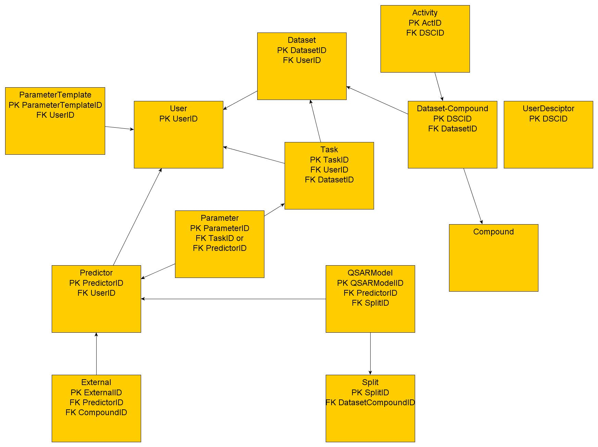

**Table: User**

Key: UserID

Fields: username (UTF-8)

Password (encrypted)

Email address

First name

Last name

Affiliation

Date registered

Date updated

Login count

Administrator (Boolean) [Note: The system will install will a default administrator name and password. The administrator will change that password and create as many other administrators as is desired. The list of administrators will always be retrieved from the database, not the XML.]

**Table: Personal Portal -- TBD**

Key: UserID

**Table: Dataset**

Key: DatasetID

Fields: UserID (foreign key for User)

Dataset name

Description

Date created

Date updated

Dataset type (enumeration: sdf_act, sdf, pdb, pdb_sdf, descriptors, descriptors_act)

**Table: Dataset Compound**

Condition: DatasetID.dataset type = sdf_act or sdf

Note: If the user tries to delete this file, we will break the link for that job but not delete it unless there are no other pointers (e.g., automatic garbage collection)

Key: DatasetCompoundID

Fields: DataSetID (foreign key for Data Sets)

CompoundID (foreign key for Compound)

Coumpound name (from SD File)

**Table: User Descriptor**

Condition: DatasetCompoundID.DatasetID.dataset type = descriptors or descriptors_act

Key: DatasetCompoundID

Fields: Descriptor string

Will we need additional information to parse the descriptor string?

**Table: Activity**

Condition: DatasetCompoundID.DatasetID.dataset type = sdf_act or descriptors_act

Key: ActivityID

Fields: dscid (foreign key for Data Set compounds)

activity type

Activity value

**Table: Task**

Key: TaskID

Fields: UserID (foreign key for User)

Status

substatus

Jobname

DatasetID (foreign key for Dataset)

Jobtype (identifies which workflow used)

Time submitted

Time started

Time completed

LSF info (TBD)

**Table: Parameter**

Key: ParameterID

Fields: reference id (foreign key either TaskID or PredID)

reference type (enumeration: task, prediction)

Parameter name

Parameter value

**Table: Parameter Template** (to be used for allowing individual defaults and extensions)

Key: ParameterTemplateID

Fields: user template name

jobtype

Parm name

Parm default value

For all users (Boolean)

UserID (foreign key for User)

**Table: Predictor** (set of models generated with one set of parameters)

Key: PredictorID

Fields: predname (default to jobname)

UserID (foreign key for User)

Time created

Description

Jobtype

(The following 3 fields are only valid when jobtype = QSAR)

y-random models built

y-random models passed training

y-random models passed test

(The following fields are optional depending on the jobtype)

External statistics (list from Sasha)

**Table: QSAR Model**

Condition: predid.jobtype = knn

Key: ModelID

Fields: PredictorID (foreign key for Predictor)

SplitID (foreign key for Split)

Training compound list

Descriptor list

k-value

Statistics (list from Sasha)

**Table: External**

Key: ExternalID

Fields: CompoundID (foreign key for Compound)

Activity type

Predicted value

Observed value

PredictorID (foreign key for Predictor)

**Table: Split**

Key: SplitID

Fields: DatasetID (foreign key for Dataset)

Split method

Random seed (need to save this)

**Table: Compound**

Key: CompoundID

**Table: Descriptor**

Key: DescriptorID